**DATABASE MANAGEMENT SYSTEM**



**TRAVEL AGENCY MANAGEMENT SYSTEM**

Created by:

* HAMZA SARWAR (02-134172-130)
* MINHAL KHALID (02-134172-056)
* JAHANGIR BUTT (02-134172-076)
* USAMA AMJAD (02-134172-135)

Submitted to:

* MISS ASMA IRFAN (Course Instructor)
* MISS SALAS AKBAR (Lab Instructor)

|  |
| --- |
|  |

# Table of Contents

Chapter 1: Introduction 3

1.1 Goals……………………….……...……………….…………………..3

1.2 Our Solution……...……...…………………………………………….3

1.3 Technical Limitations…...……………………………………………..3

Chapter 2: Methodology 4

2.1 Methodology.……………..…………………………………………..4

2.2 Purpose…...……………………………..…………………………….4

Chapter 3: ERD 5

Chapter 4: Screenshot & Description………………………………………..6

Chapter 5: Conclusion……………………………………………………...12

5.1 Conclusion…………………………………………………………...12

5.2 Future Work………………………………………………………….12

# ***INTRODUCTION***

Traveling has come a long way from bus to train, and train to air. Traveling is always an adventure, watching, experience and seeing new places. Our project is about travel agency that will provide secure ways of travelling from transport to hotel, vary with different type and class according to customer’s need. The world has come a long way in computing and with time travel agency also got an upgrade from taking note of all the details and record on a piece of paper. With this project all the record that wasted time in collecting, saving and guarding will be now all stored efficiently using database, usable on any computer. This project is made using sql queries to create database which is our backend whereas Java is used to create GUI which is our frontend.

* ***GOAL***

Goal is to create a Travel Agency Management System which ensures the Safety and security of the travelling and provides user friendly environment to the customer with agent. The agent will be able to book customer without any complications and doing it in simple way.

* ***OUR SOLUTION***

A Custom travel agency management system is made for the purpose of ending huge piles of paper getting gathered by the entries of customer and by the information of agent or admin related information. With this booking of customers, payment and information on them is stored in database through sql queries.

The system can save record of agent, admin, customer, booking and payment as well as package. With this the travel agency is now more effective and easy to handle.

* ***TECHNICAL LIMITATIONS***

This system is restricted to admin only. However, admin is able to provide rights to agent so that he may make booking and payments. Similarly, Admin can provide right to Customer. However, all records entered are need to be saved in database. As our course didn’t cover internet enabled database this system lacks in that including some other things.

# ***METHODOLOGY***

This project is made using subject Knowledge of sql and database management. Basic actions like Insertion, Searching, Updating and Deletion are done through sql queries which are connect with GUI inside buttons whereas the data is stored in database. This is a GUI based project, which not only makes travel agency’s work efficient but also provide security to Admin and Agent both with all the basic requirements needed for a travel agency.

* ***PURPOSE***

#### **1. Managing Bookings**

Travel Agency Management System helps you efficiently and effectively manage your bookings. Neither you, nor your staff, should be tasked with manually input bookings. This system should automate the booking process for you, allowing you to escape the back office and focus more on interacting with your customer.

#### **2. Customer’s Satisfaction**

You will develop a better rapport with your target market segment, while also identifying new markets to tap into. The types of travelers who have always loved using this system will appreciate the improved experience. In addition, your new technology will allow you to reach out to new markets that would not have otherwise discovered your brand.

* ***PROJECT ERD***

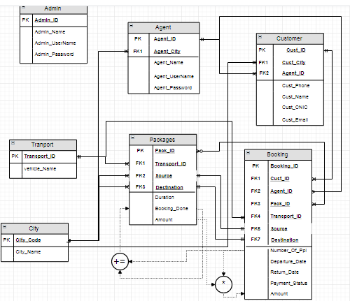

# ***SCREENSHOT & DESCRIPTION***

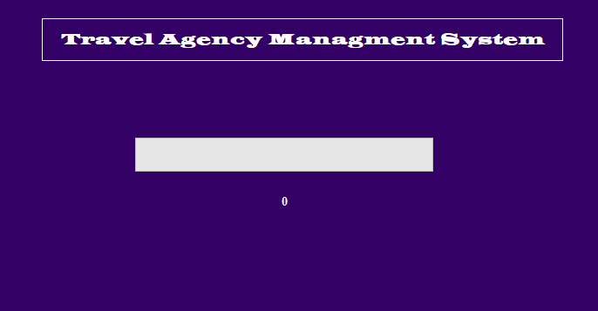

**MAIN PANEL**

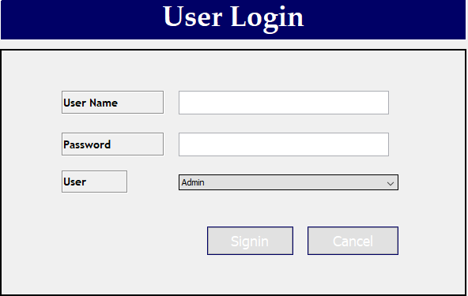

**LOGIN PANEL**

**ADMIN WORK:**

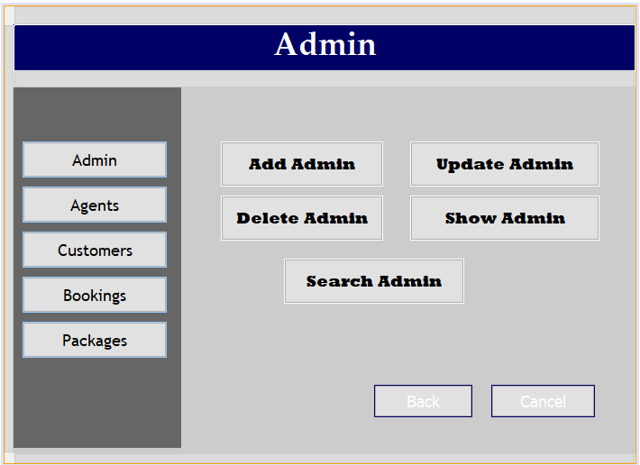

**ADMIN MAIN PANEL**

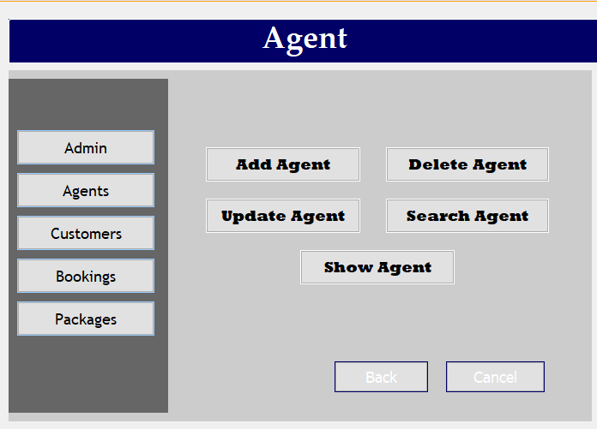

**ADMIN (AGENT) PANEL**

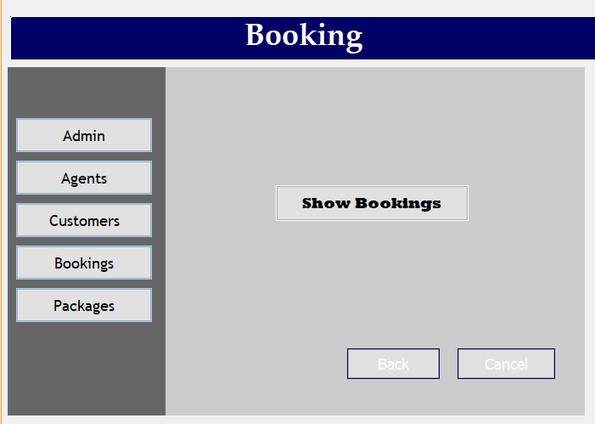

**ADMIN (BOOKING) PANEL**

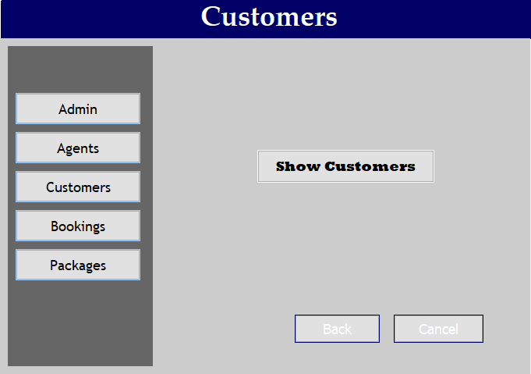

**ADMIN (CUSTOMER) PANEL**

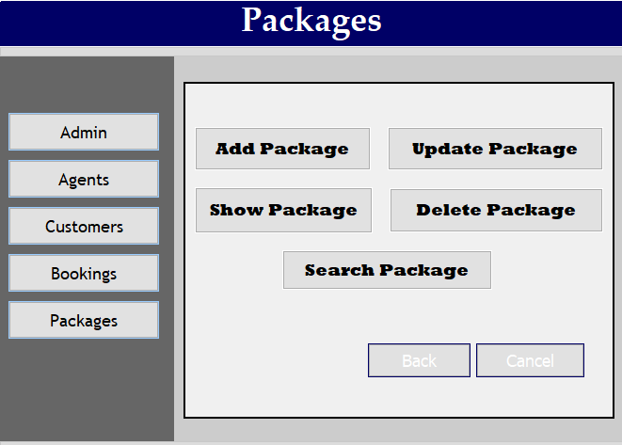

**ADMIN (PACKAGES) PANEL**

**AGENT WORK:**

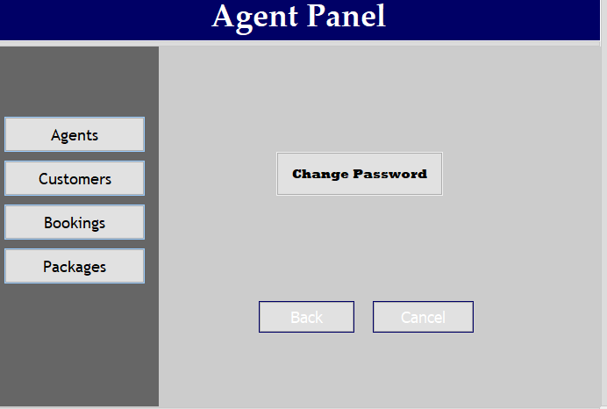

**AGENT MAIN PANEL**

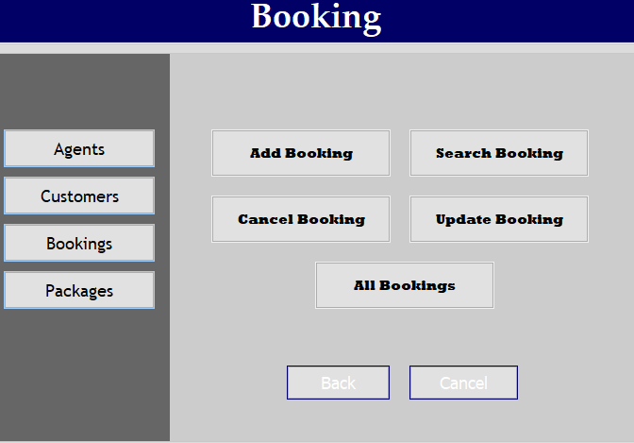

**AGENT (BOOKING) PANEL**

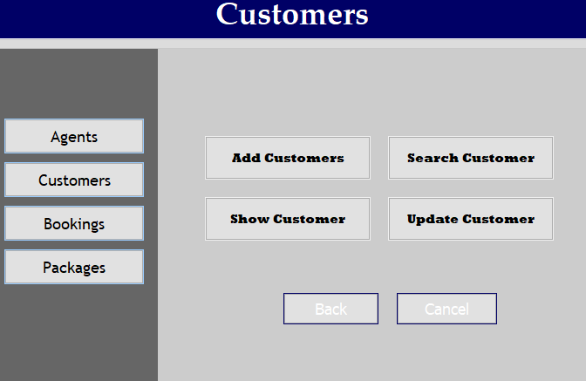

**AGENT (CUSTOMER) PANEL**

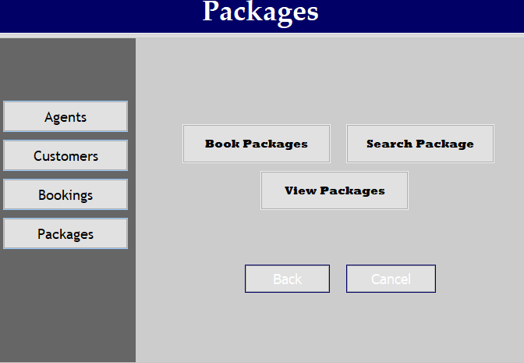

**AGENT (PACKAGES) PANEL**

**CUSTOMER WORK:**

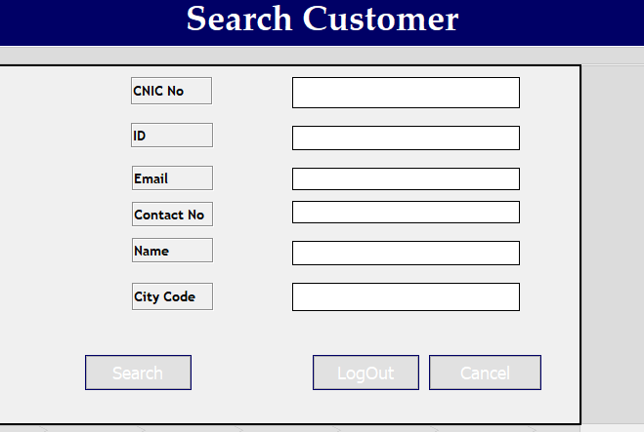

**CUSTOMER DASHBOARD PANEL**

# ***CONCLUSION***

* ***Conclusion***

After reviewing our work, the conclusion is that after many adjustments the system works. As good as it is now, there can still be made many adjustments / improvements. The overall results are satisfactory in our opinion. The report covers the entire course of the project and results are there where needed. This conclusion chapter is more a description of the process rather that a summary to give all results and facts.

The first week the work progressed slower than expected, in the last week the pace was increased to finish on time. The results of this report should be sufficient evidence that work was done properly.

* ***Future Work***

The Features of this system can be improved as it was first basic project yet it is capable to perform all basic tasks required in travel agency management system so that it may save precious time and human energy. It is a kind of introduction to computational work which in future can also be enhanced as with the time the requirements changes.

* **REFERENCE**
* MISS ASMA IRFAN
* MISS SALAS AKBAR